JOB APPLICATION FORM MANAGEMENT
EXPERIMENT 6: Workflow Automation using Deluge
Name | Sadhana M
Roll No | 241401085
Department | CSBS

Workflow Automation using Deluge — Job Application Form

1. Aim
To automate the approval and notification process of the "Job Application Form" application in Zoho Creator using Deluge scripting, so that every application submitted by a candidate is automatically routed to HR for review, an acknowledgement is sent the moment a form is submitted, and the candidate is notified by email once the HR review is completed — without any manual intervention from the recruitment desk.

2. Procedure

2.1 Creating the Approval Workflow
1. Open the Workflow tab of the Job Application Form application and go to the Approvals section. Choose the form "Job Application" on which the approval process must run.
2. On the "Run approval process on record addition" screen, select the form, name the workflow "HR approval", and set the process to run Always so that every new application automatically enters the approval chain the moment it is submitted.
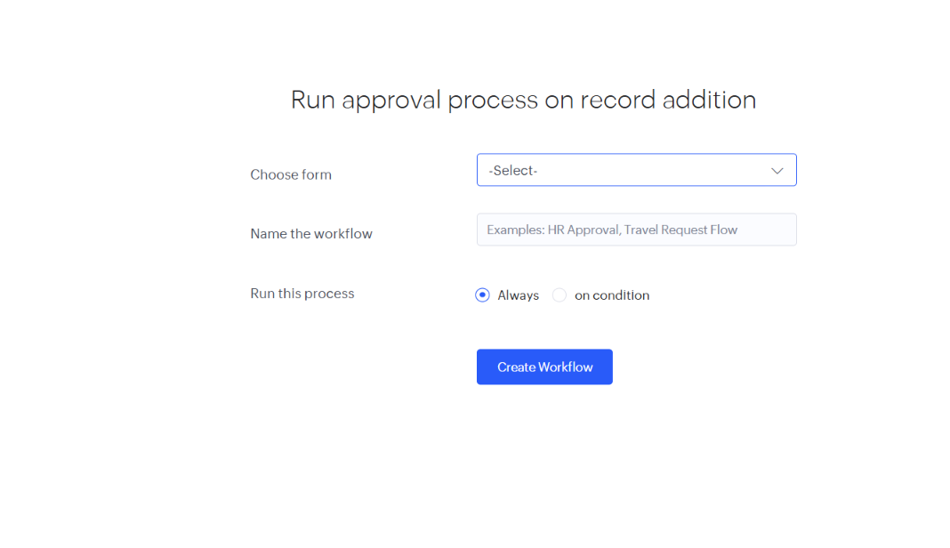
Explanation: This screen configures the approval trigger for the recruitment process. Selecting the "Job Application" form and setting the run condition to "Always" ensures that as soon as a candidate submits the application form, the record is automatically pushed into the approval pipeline for HR's review, with no separate condition needed to activate it.
3. In parallel, a form-level workflow is created under "Run workflow on any event in the form" so that an acknowledgement mail and other record-level actions (create/edit/delete) can be triggered independently of the approval chain.
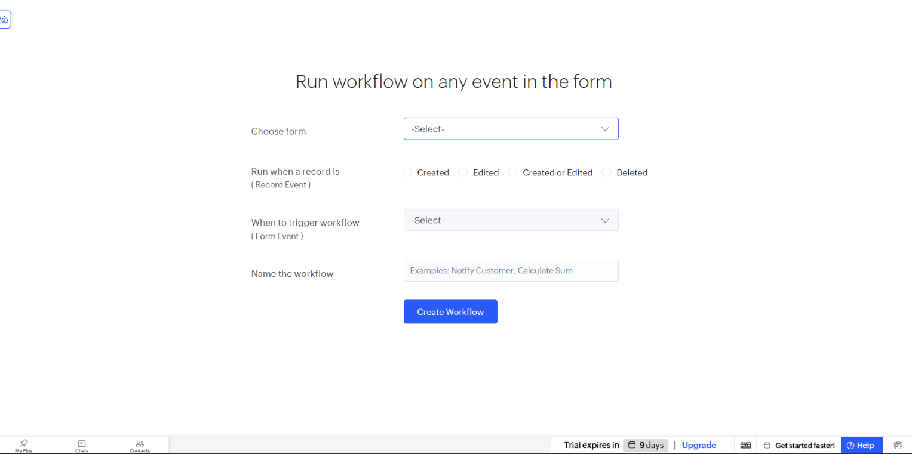
Explanation: This screen lets the workflow fire on a chosen Record Event (Created, Edited, Created or Edited, or Deleted) combined with a Form Event such as successful submission. Setting the Record Event to "Created" and naming the workflow "Notify customers" keeps this automation organised and identifiable on the Workflow dashboard — it is this workflow that later sends the confirmation mail to the candidate as soon as the form is submitted.

2.2 Choosing the Trigger and Writing the Deluge Script
4. When adding a new action, Zoho Creator asks "When do you want to run your action?". The options available are On a form event, On a scheduled date, On a function call, On batches of records, On an approval activity, On a payment activity, and On a business process. For this automation, On an approval activity is selected so the Deluge script executes right after HR approves or rejects an application.
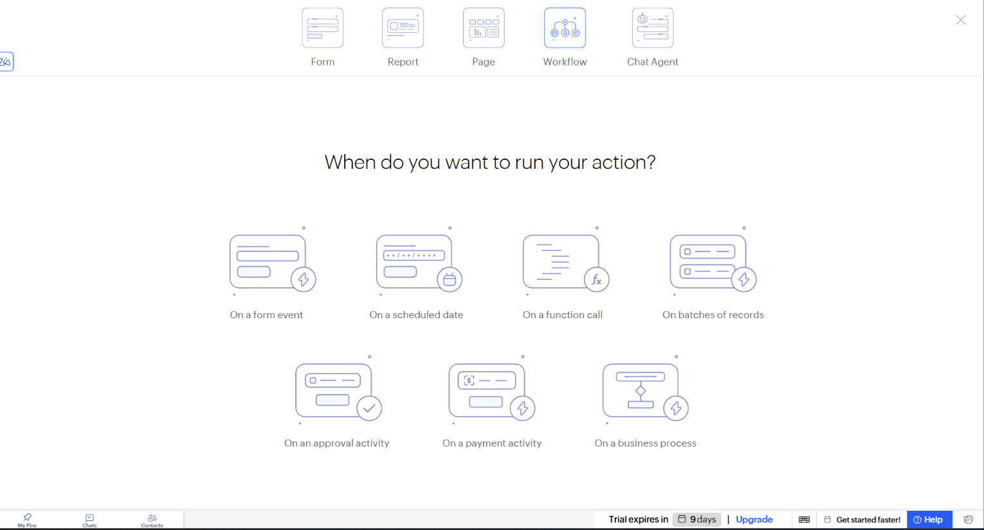
Explanation: Each trigger type maps to a different real-world moment in the hiring process. Choosing "On an approval activity" ties the Deluge script directly to the outcome of the HR review step, instead of running on every save, which keeps notifications limited to genuine status changes on a candidate's application.
5. In the Approvals tab, the "Job Application" approval named "HR approval" is configured to run On review, branching into an approved path and a rejected path. Each path is attached to Deluge scripts that send a mail to the candidate's ${Email_Address} and push an in-app notification to the HR reviewer, with 2 actions enabled overall for this approval.
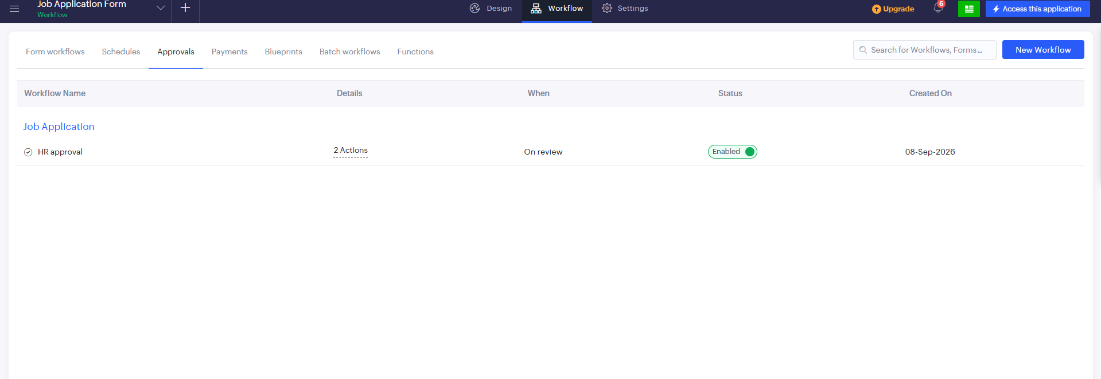
Explanation: This is the core of the automation. One Deluge script sends the candidate an email confirming that their application has been shortlisted for the next round, while the other sends a rejection mail instead — so the correct notification fires automatically depending on the HR reviewer's decision. The workflow is marked Enabled, and "2 Actions" confirms both the approved and rejected branches are live.
6. A scheduled workflow named "DAILY REPORT" was also created under the Schedules tab, set to run a single Deluge action at a fixed time each day. This is intended to compile a daily summary of applications received for the recruitment team, and is kept in the same application so it can be enabled independently of the candidate-facing notifications.

3. Output
Once the approval workflow and its Deluge scripts were published, every application submitted through the Job Application Form began flowing through the automated approval chain, with HR able to track pending and completed reviews from dedicated tabs.

Form Workflows
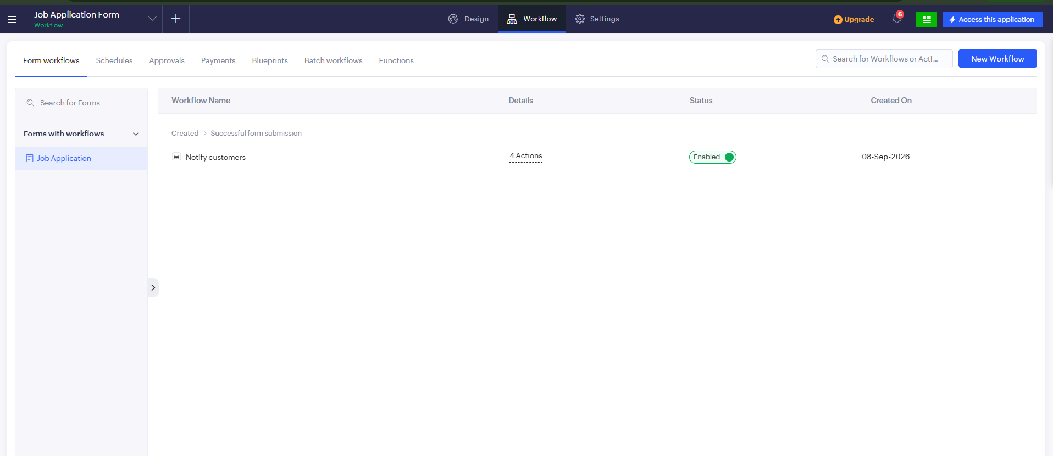
Explanation: The Form workflows list under the Workflow tab shows the "Notify customers" automation running on the Job Application form, triggered on "Created > Successful form submission" with 4 Actions attached. It is marked Enabled and was created on 08-Sep-2026, confirming that the acknowledgement automation fires live every time a candidate submits the form, running the validation, confirmation-mail, and record-update scripts together.

Schedules
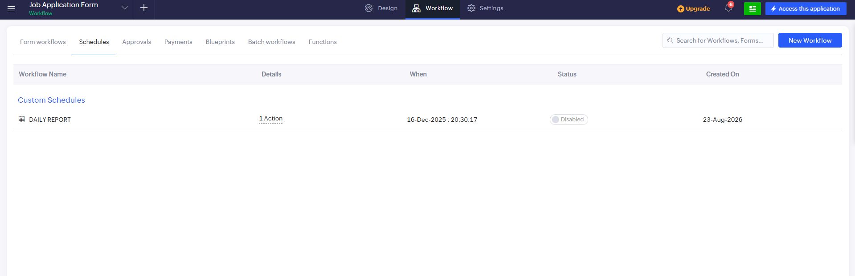
Explanation: The Schedules tab lists the custom "DAILY REPORT" workflow, with 1 Action set to run at 16-Dec-2025, 20:30:17. Its status is shown as Disabled, meaning the daily summary script has been created and configured but is intentionally switched off until the recruitment team is ready to start receiving the automated daily digest.

Approvals
Explanation: The Approvals tab confirms the "HR approval" workflow under the Job Application form, running "On review" with 2 Actions and marked Enabled, created on 08-Sep-2026. This is the same approval chain described in the Procedure section, now live and actively routing every incoming application to HR.

Pending Tasks
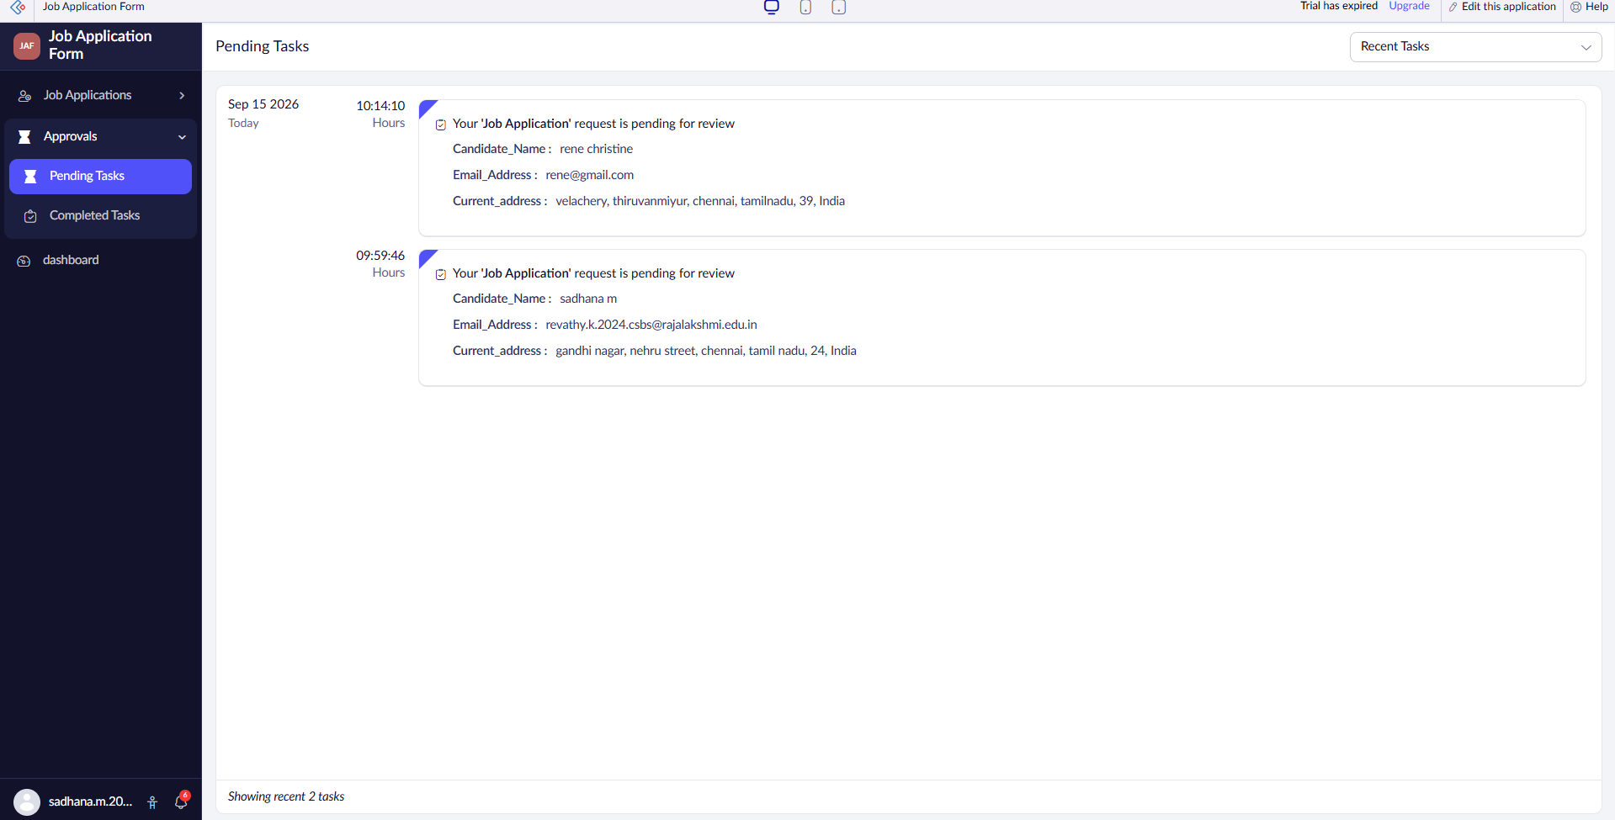
Explanation: The Pending Tasks screen lists every job application still awaiting HR review — here, applications from candidates Rene Christine and Sadhana M are shown, each with the candidate name, email address, and current address that the Deluge script will use once a decision is made. This confirms that the "On Start" trigger correctly queued each new submission for approval as soon as it was created.

Completed Tasks
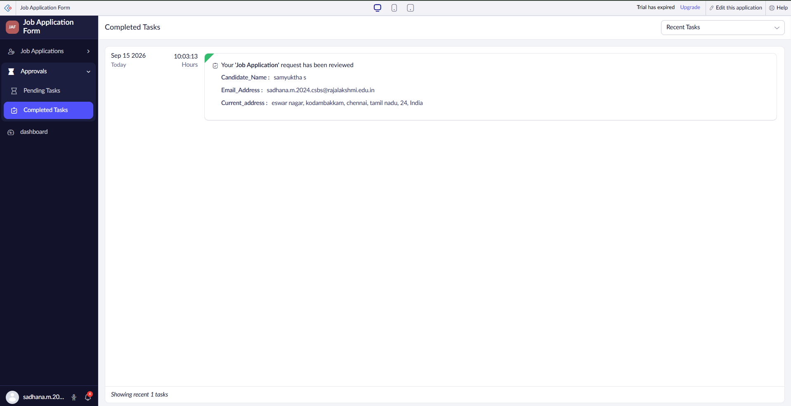
Explanation: The Completed Tasks screen shows a request after HR has acted on it — candidate Samyuktha S's application has been reviewed. This confirms that the approved/rejected Deluge script executed correctly, moving the record out of Pending Tasks and triggering the corresponding candidate notification automatically.

4. Result
An approval-driven workflow automation was successfully built for the "Job Application Form" application using Deluge scripting in Zoho Creator. Every new application is automatically queued for HR review, a confirmation mail is sent to the candidate the moment the form is submitted, and Deluge scripts attached to the approved and rejected branches of the HR approval automatically send an email and an in-app notification once a decision is made. A daily-report schedule was also configured for the recruitment team, ready to be enabled when needed. This eliminates manual follow-up, ensures every job application is reviewed in a consistent, traceable manner, and keeps both the candidate and the recruitment desk informed in real time about the status of each application.

